Name : Khushi Panwar

Roll No : 2021334

SEC (Python) PRACTICAL ASSIGNEMENT : 20.10.2022

Computer Science (3rd Sem)

**Question 1 : WAF to show different sorting techniques (bubble, insertion and selection)**

**Solution 🡪**

def insertionSort(arr):

for i in range(1, len(arr)):

key = arr[i]

j = i-1

while j >= 0 and key < arr[j] :

arr[j + 1] = arr[j]

j -= 1

arr[j + 1] = key

return arr

def bubbleSort(arr):

size=len(arr)

for i in range(0,size-1):

for j in range(0,size-1):

if arr[j]>arr[j+1]:

arr[j], arr[j+1]=arr[j+1],arr[j]

return arr

def selectionSort(arr):

size=len(arr)

for i in range(size-1):

min=i

for j in range(min+1, size):

if arr[j]<arr[min]:

min=j

if i!=min:

arr[i], arr[min]=arr[min], arr[i]

return arr

print("\n ** PROGRAM TO PERFORM SORTING ON A LIST OF ELEMENTS **\n\n ")

ch='y'

while(ch=='yes' or ch=='Y' or ch=='y'):

lst=list(map(int, input("Enter all the elements for the list here : ").split()))

print("\n-> The elements entered are ", lst)

choice=int(input("\nChoices Available - \n 1. Bubble Sort \n 2. Insertion Sort \n 3. Selection Sort \n Enter the choice here : "))

print()

if choice==1:

result=bubbleSort(lst)

print("Resultant list after BUBBLE SORT : ", result)

elif choice==2:

result=insertionSort(lst)

print("Resultant list after INSERTION SORT : ", result)

elif choice==3:

result=selectionSort(lst)

print("Resultant list after SELECTION SORT : ", result)

else:

print("** INVALID CHOICE** ")

print()

ch=input("-- Do you wanna continue?? (y/n) : ")

print()

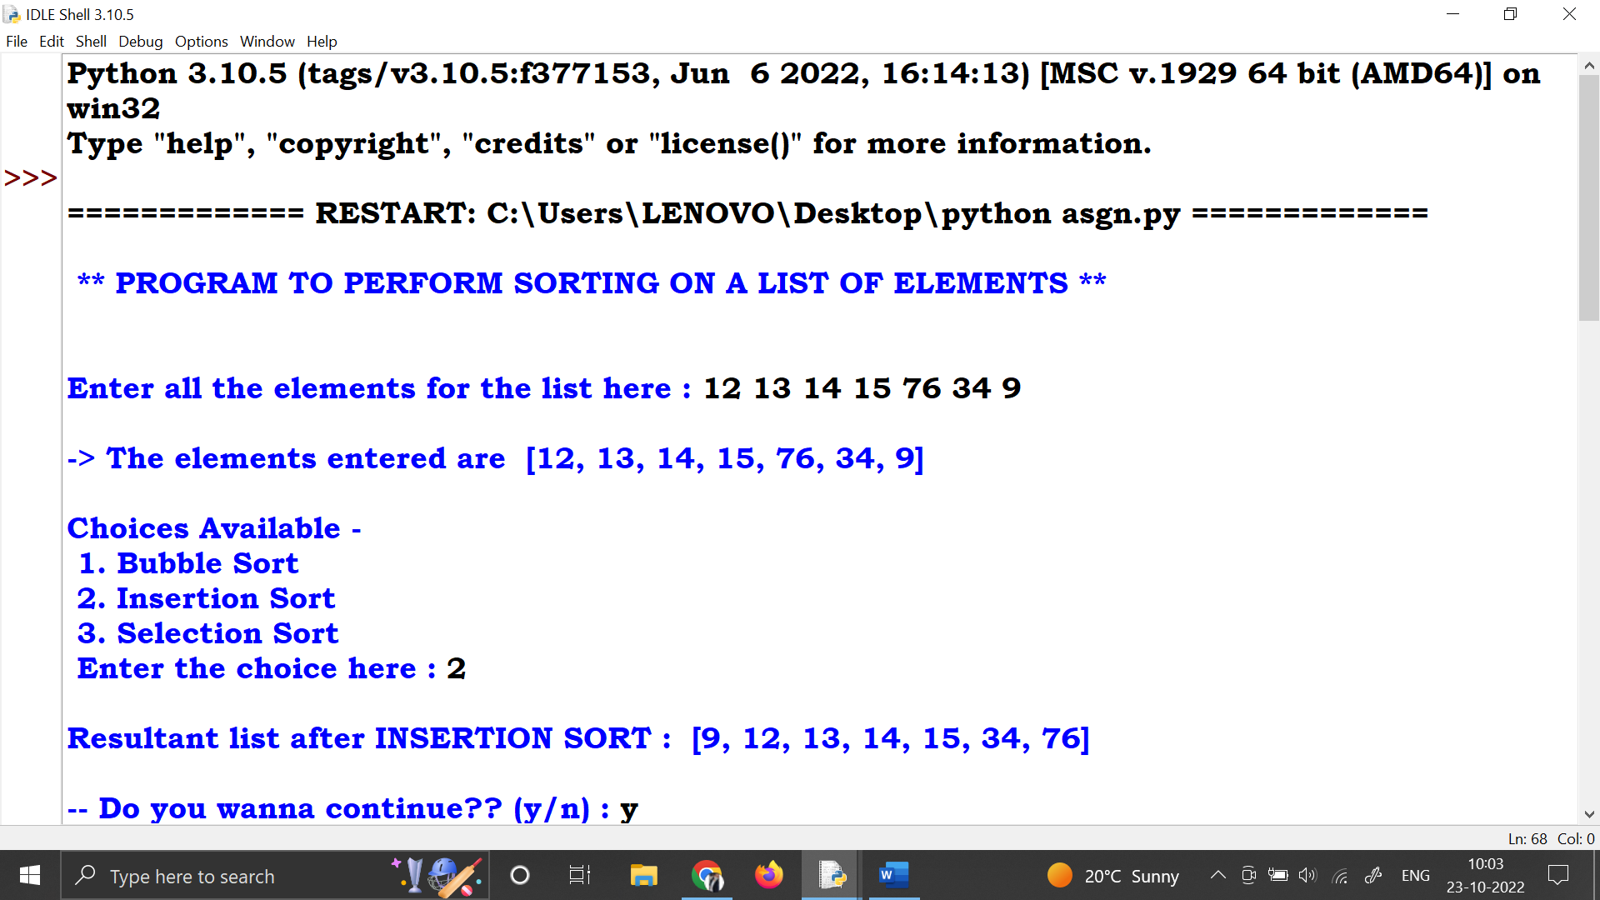

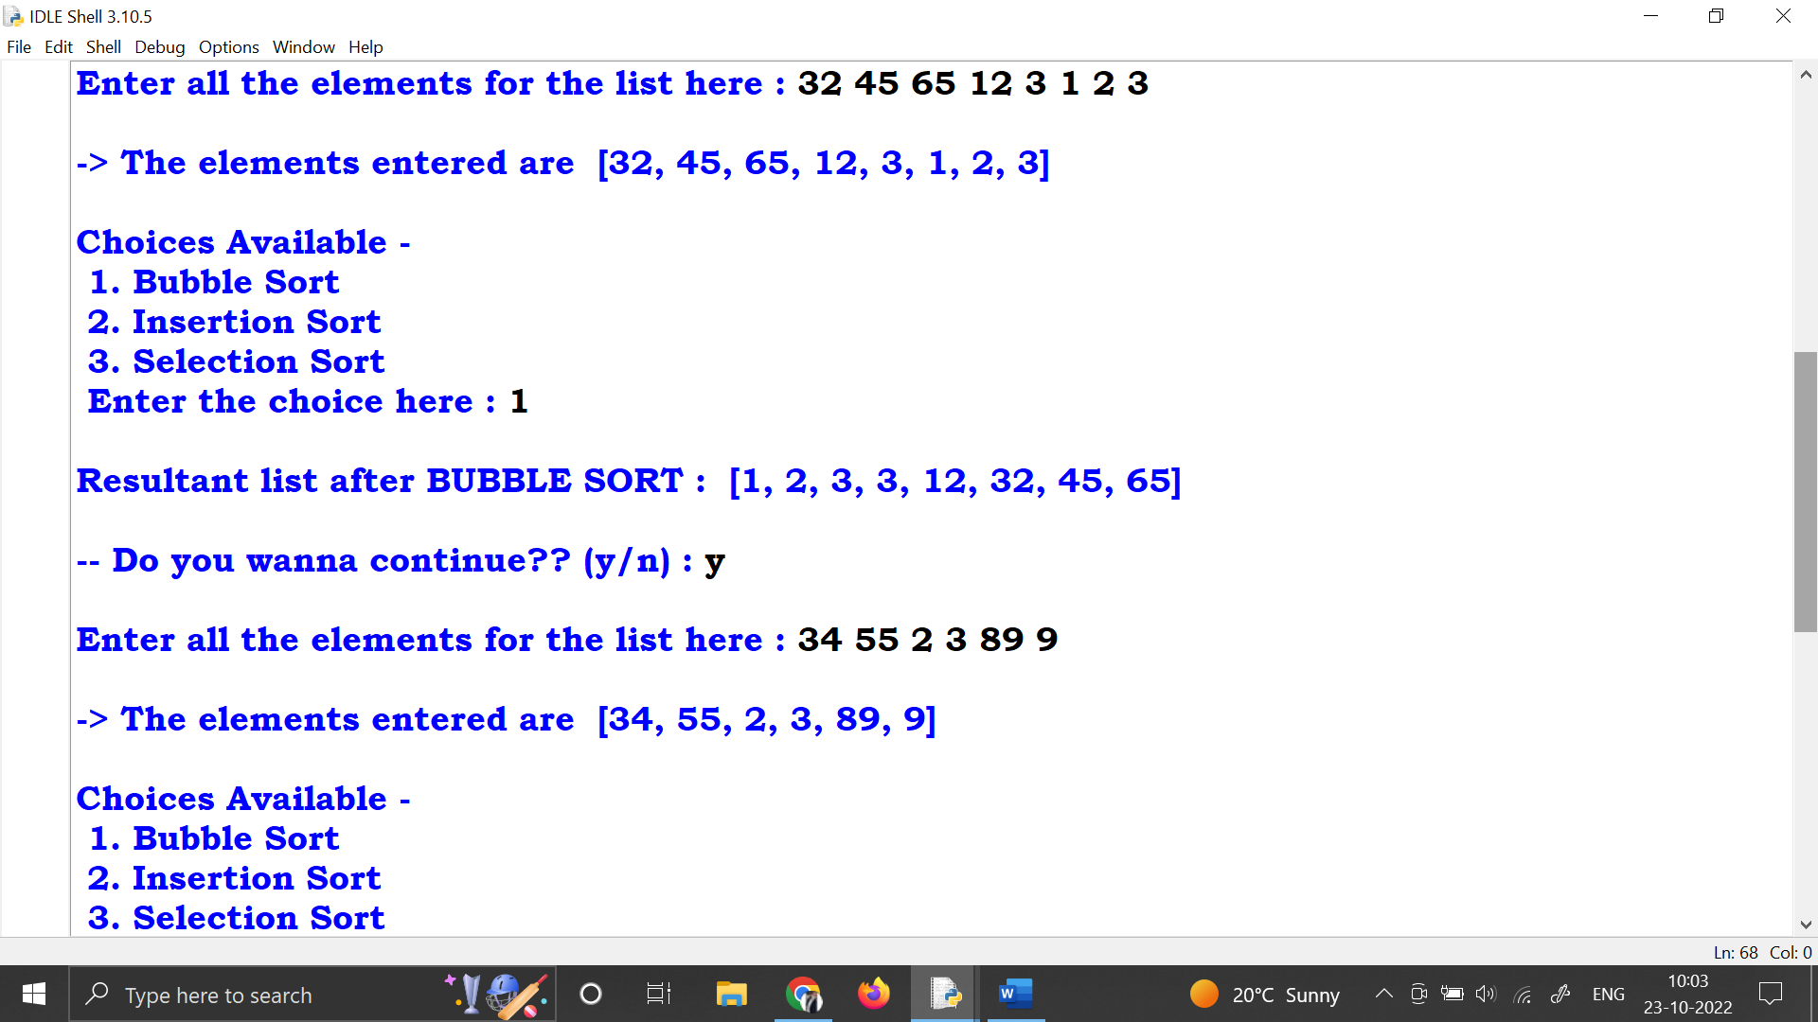 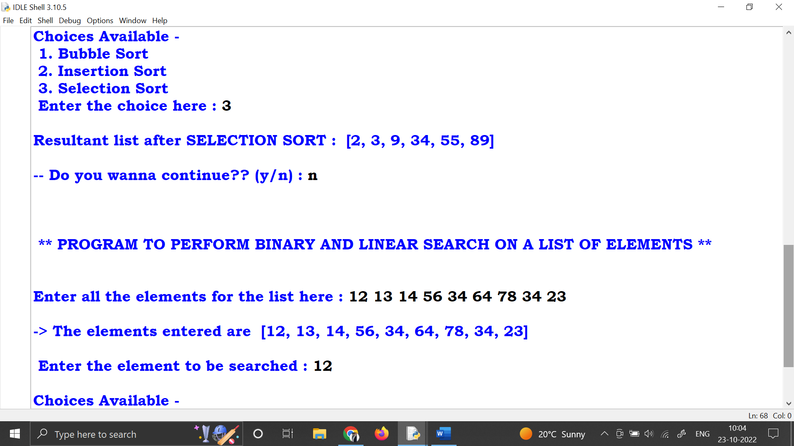

**Question 2 : WAF to show different searching techniques (linear and binary)**

**Solution 🡪**

def linearSearch(lst, ele):

for i in range(len(lst)):

if lst[i]==ele:

return i

return 0

def binarySearch(lst,start, end,x):

if (end>=start):

mid=(start+end)//2

if lst[mid] == x:

return mid

elif lst[mid] > x:

return binarySearch(lst, start, mid - 1, x)

else:

return binarySearch(lst, mid + 1, end, x)

else:

return -1

print("\n ** PROGRAM TO PERFORM BINARY AND LINEAR SEARCH ON A LIST OF ELEMENTS **\n\n ")

ch='y'

while ch=='y' or ch=='Y' or ch=='Yes':

lst=list(map(int, input("Enter all the elements for the list here : ").split()))

print("\n-> The elements entered are ", lst)

ele=int(input("\n Enter the element to be searched : "))

choice=int(input("\nChoices Available - \n 1. Linear Search \n 2. Binary Search \n Enter the choice here : "))

print()

if choice==1:

result=linearSearch(lst, ele)

if result>0:

print("Element found at ",result, " index in list.")

else:

print("Element not found! ")

elif choice==2:

result=binarySearch(lst, 0, len(lst)-1, ele)

if result>0:

print("Element found at ",result, " index in list.")

else:

print("Element not found! ")

else:

print("Invalid choice! ")

print("** PROGRAM ENDS HERE **")

